Ruari Theakston

Jesus College, Jesus Lane, CB5 8BL

(+44) 7842 770756 | rt600@cam.ac.uk | linkedin [LinkedIn](https://www.linkedin.com/in/ruari-theakston-70048812a/)

**Education**

Jesus College, University of Cambridge Oct. 2022 – June 2026

**MENG ENGINEERING**

* Electrical engineering covering linear circuits and devices, electrical machines, electromagnetic fields and waves, physical principles of electronics, digital circuits, and information processing.
* Information engineering covering linear systems and control, signal and data analysis, communications.
* Mathematical methods covering vector calculus, linear algebra, probability.
* Mechanics covering mechanical vibrations.
* Structures covering structural mechanics.
* Materials.
* ThermoFluid mechanics.

**Coursework**

* 1st place in the Cambridge engineering Mars-Lander summer exercise where students were tasked with writing an autopilot for a C++ Mars lander application. I added a moon to the main planet, wrote an autopilot for complex actions like a suicide burn, and orbital transfers using the most efficient method (Hohmann transfer) created an autopilot that automatically performs a bi-impulsive moon transfer and moon landing, etc. Received the 1st place prize of £200 for my work.
* Lego Mindstorms in first year where my team built a working pendulum clock and integrated design project in second year, both practicing the skills of creating a successful engineering solution to a complex task/problem.
* Integrated electrical project experimenting with different circuit components and test their real-life properties in comparison to what out theoretical knowledge teaches us. This led to a project of building a functioning electronic thermometer, among other tasks.
* Working on microprocessors to learn to program in machine code.
* Management skills including writing an essay on the wider issues that influence technical decisions.
* Drawing skills using SolidWorks and manual drawing, emphasising the principles and practices that define how three-dimensional objects are represented on two dimensional surfaces.
* Product design project where we design a device to meet a specified need as well as presenting our final ideas to an audience.
* Giving a presentation on a prepared topic, writing professional laboratory reports, and taking part in debates to practice communication as an engineer.
* Computing and numerical analysis - learn how to analyse engineering problems using Python.
* Structural design project where we design, manufacture, and test a metal structure to carry specific loads at minimum cost.
* Laboratory experiments and professional reports

**Queen Ethelburga’s Collegiate Yorkshire** Sept. 2020 - Jul. 2022

A level Physics (A*), Mathematics (A*), Further Mathematics (A*), EPQ (A*)

**Experience**

**UKESF Scholarship at Swindon Silicon Systems (Part of Sensata Technologies)** June 2023– Oct 2023

In charge of a main project for the duration of the internship (14 weeks in the Summer) as well as helping on various other tasks around the company.

* Developed a prototype for a (possible) future TPMS (tyre pressure monitoring sensor) solution the company will sell to automotive customers that require BLE (Bluetooth low energy) tyre monitoring over the conventional RF (radio frequency) Gen7 we currently sell.
* The prototype mentioned earlier was especially challenging as the concept was to demonstrate that it is possible to remove the intelligence/processor from our current TPMS and still maintain all the usage by having a master chip running the same code but accessing and modifying all the sensor registers over SPI and a theoretical digital logic solution on the TPMS end. The objectives for the TSA prototype were:
  + Run all the original sensor c-code unmodified on a master (silabs arm) chip.
  + Retain all the functions of the original sensor solution, but gain flexibility as being able to run the sensor from any microcontroller allows for quick product development and great flexibility allowing us to better cater to automotive customers like Tesla who want new sensors that support BLE and more features.
  + Somehow do the above but force all register accesses in the code to be performed over SPI.
* I was able to accomplish all the above through various means:
  + Compiled all the original sensor code in C++ and created an SPI location class which operator overloads all the volatile uint_16t* used in the original code to SPI transactions.
  + Put this in a separate part of the Silabs code as this all must be compiled in c for the silabs toolchain and used special techniques in c to allow c-code to run/call the c++ functions it needed to run the sensor code on the master chip.
  + Modified the makefile of the massive sensor project so that the c and c++ areas of the silabs code are compiled separately and then linked together without issues.
  + Utilised conditional compilation, header file rerouting (or that’s what I call it at least), extern c and similar techniques to make it all compile.
  + Debugged the SPI transactions for controlling the Sensor registers over an oscilloscope as the tiny sensor processor does not support debugging over gdb except over SPI but these pins were already used by my projects SPI needs.
* After completing the prototype, I created a roadmap of how to bring the tyre pressure read time of the prototype down from 315ms to an acceptable 30ms through various techniques that would be possible in the case that TSA would be created in a digital logic form and if more funds and engineers were allocated to it.
* Delivered a presentation of my project to a range of people at the company, some who had never seen the project before and was able to effectively describe the entire thing and fully explain the advantages, disadvantages, and obstacles to a successful TSA. Presentation was described as ‘excellent’ ‘very interesting’ and convinced the person in charge of funding and planning TSA of why it is worthwhile and possible, while effectively warning of the great development costs involved.
* Assisted the team in various workflow efficiency increases:
  + Helped the team transition from working on Eclipse to VS-Code (including doing debugging and building from the VS-Code GUI with Json scripts).
  + Worked as a ‘guinea pig’ for demonstrating that most Linux activities usually ran on servers at the company can be done on personal office computers using WSL (windows subsystem for Linux) such as running scripts, building projects, etc.
* Wrote a Debian package called Silabs-Flasher which automates the process of flashing our sensor on its devboard (which is attached to a larger Silabs devboard that does the actual flashing) over JLINK, to be used in a larger package that I worked on integrating it into and adding as a requirement in the Debian package, etc to be given to internal and external customers. (Learned all about Debian packaging, testing compatibility with docker containers, etc)

**Cambridge University Eco Racing Society** Oct. 2023 – Present

In charge of the design of PCBs and systems for the driver interface.

* This involves taking data from systems across the electric car we are building (7th generation/iteration of our car) and passing all the data over the relevant protocols onto a single main PCB and microcontroller which then displays the relevant data to the driver (think current velocity, throttle level, battery remaining, etc).
* Currently this is done by a Raspberry Pi, but this involves a high-power consumption and bootup time, so I must design a PCB with a more efficient and embedded solution such as an arm microcontroller and OLEDs that it controls to perform the same tasks efficiently.
* Developing further my embedded design and programming skills gained at my summer internship and personal projects.

**Cambridge University Space Flight Lead Engineer for Antenna design** Oct. 2022 – June 2023

In charge of the design of an antenna to allow for data transmission from the Griffin rocket back to the ground receiver.

* Managed the design of an antenna system for the Griffin rocket, ensuring efficient data transmission back to the ground receiver.
* Delved deep into the study of microstrip patch antennae, focusing on specifications for frequency, bandwidth, and durability, given the rocket's 150km apogee and Mach 4+ speeds.
* Developed a systematic approach, supported by software tools, for designing antennae. This included simulations and mathematical modelling to ensure optimum performance.

**EPQ – The future of the Consumer Electronics Market** Jun. 2021

* Wrote an article on driving factors of the consumer electronics market, using factors such as climate change, scarcity of resources, and differing business models' methods for ensuring recurring profits to assess the likelihood of different markets for computing and technology in the future.
* Built a working, modular laptop (although the chassis isn’t complete yet) from PC parts to demonstrate the feasibility of repairable, upgradeable products as a solution for this issue to contrast the current, working, and efficient model of cloud-based subscriptions for computing.
  + Built a battery and charging system using diodes, voltage transformers and a battery pack I designed to fit my specifications, allowing the laptop to be used anywhere.
  + Salvaged parts such as a panel and antennae from an old laptop using various boards from eBay and Taobao to allow the electronics to interface with a PC motherboard that has laptop ram slots.
  + Designed parts in blender and 3D printed the spacers and board covers required for the project on my Ender 3 V2 3D printer kit.
  + Operated a drilling machine to create the correct holes in aluminium sheets for the chassis

**Siemens virtual work experience** Apr. 2021

* Delved into problem-solving methodologies to explore how engineers address macro challenges like climate change.

**Personal projects**

* Designing and building a Bluetooth modular split keyboard currently.
* Coded 2D games and a 3D graphics engine in C++ during the summer following tutorials on YouTube.
* Strong Python knowledge from regular practice and, again, from coding tutorials and projects online.
* Very comfortable using Linux or Windows, command line or GUI as I have used each extensively e.g., for my laptop project as part of my EPQ I installed the Arch Linux ISO and built my own operating system off that.
* Strong 3D design skills in software such as SolidWorks and Blender from my DIY 3D printer and coursework.

**Extra-curricular**

**Jesus College Ambassador** Nov. 2022 - present

* Representing the College enabling a wider range of people to consider Oxbridge.
* Outreach events such as touring Hampton College around Jesus or the Northeast schools' trip where we visited under-represented areas in the Northeast for a week.

**German Intermediate Course** Nov. 2022 – June 2023

* Learned German vocabulary and skills related to engineering.

**Ultimate Frisbee** Oct. 2022 - present

* Attending regular training sessions with 10 other players, working on our team playing skills and tactics on a regular basis and playing matches every weekend.

**Jesus College Rowing M2** Oct. 2022 - present

* Staying fit in the rowing club.
* Attending regular races and training.
* Attending regular socials.

**Army Cadet Force** During 6th form, no longer member

* Good teamwork/leadership skills from being a member of the ACF in my 6th form conducting various tasks ranging from working in a squad/team exercises to instructing other cadets in formal lessons.

**Languages**

* Fluent in English and Finnish.
* German – Able to use professionally.

**Referees**

Prof Thierry Savin, Director of Studies, Department of Engineering, University of Cambridge [t.savin@eng.cam.ac.uk](mailto:t.savin@eng.cam.ac.uk)

Mortimer Liuba Jones, head of HR at Swindon Silicon Systems [liubovmortimer-jones@sensata.com](mailto:liubovmortimer-jones@sensata.com)

**Pictures of recent personal projects**

The laptop (up close) working off the battery pack and my laptop and 3D printer side by side, repairing my mouse

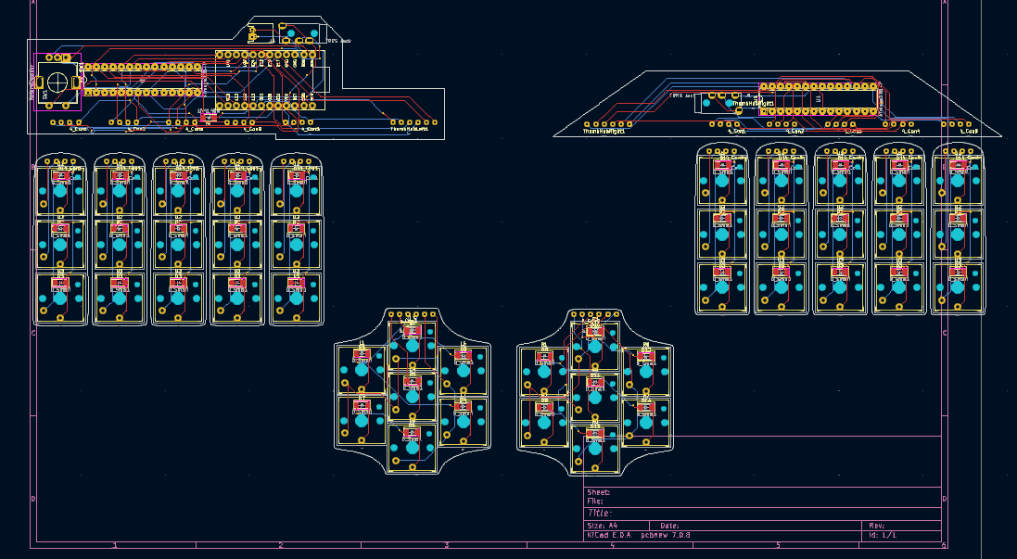

Prototype PCB of my keyboard I am building. Currently stuck on modifying some open-source keyboard software running on ZEPHYR RTOS but once I’ve learnt that it will be ready to polish the design.